

DATA ANALYTICS AND MACHINE LEARNING
PAP Prediction of Process Parameters
Internship Project Report
Submitted By
Name: Mutyala Nivedh
Department: Computer Science and Engineering (Artificial Intelligence & Data Science)
College: Bonam Venkata Chalamayya Engineering College(Autonomous) (BVCEC)
University: Jawaharlal Nehru Technological University, Kakinada (JNTUK)

Internship Details
Organization: Coromandel International Limited

Project Title: PAP Prediction of Process Parameters Using Data Analytics and Machine Learning

Duration: 15 May 2026 – 30 June 2026

Mentor:
TABLE OF CONTENTS
S.no | Contents | Page No.
1 | Cover Page | 1
2 | Table of Contents | 2
PART – I : THEORY
3 | Data Types and Statistics | 4 – 7
4 | Data Cleaning and Preprocessing | 7 – 12
5 | Data Visualization | 13 – 20
6 | Exploratory Data Analysis (EDA) | 21 – 26
7 | Time Series and Discrete Data | 27 – 30
8 | Machine Learning Algorithms | 30 – 63
9 | Model Performance Metrics | 64 – 69
PART – II : PAP PREDICTION OF PROCESS PARAMETERS
10 | Project Objective and Dataset Understanding | 70 – 72
11 | Data Preprocessing and Feature Engineering | 73 – 75
12 | Machine Learning Model Investigations | 76 – 84
13 | Random Forest Analysis and SHAP Explainability | 85 – 89
14 | Final Model Comparison and Conclusion | 90 – 92

1)Data Types and Statistics
What are Data Types?
Data types tell us what kind of information we are working with.
Purpose
Understanding data types helps us choose the correct analysis and visualization methods Different Data Types
Int
A whole number without decimals.
Examples
10 ,-25
Statistics Commonly Used

Mean, Median, Mode, Min, Max, Range, Variance, Standard Deviation

Float
A number with decimal values.
Examples
10.5 ,25.75
Statistics Commonly Used
Mean, Median, Mode, Variance, Standard Deviation, Percentiles
String (str)
Text data.
Examples
"John" ,"Bangalore"
Statistics Commonly Used
Count, Frequency, Unique Values, Value Counts

Character (char)
A single character.
Examples
'A' ,'B'
Statistics Commonly Used
Count, Frequency, Unique Values, Value Counts
Boolean (bool)
Stores only two values.
Values
True or False
Statistics Commonly Used
Count of True/False, Percentage, Proportion

Date
Stores calendar dates.
Examples
2026-05-29,2025-01-15
Date
Year, Month, Day, Day of Week, Time Difference
Time
Stores time values.
Examples
10:30 AM ,14:45 PM
Statistics Commonly Used
Hour, Minute, Second, Duration Analysis
Datetime
Combination of date and time.
Example
2026-05-29 10:30:00

Time Series Analysis, Trends, Seasonality, Time Differences
Statistics
What is Statistics?
Statistics is the process of collecting, analysing, and understanding data.
Purpose
Understand data better
Find patterns and trends
Support decision-making
Summarize large amounts of data
1. Mean (Average)
The mean is the average of all values.
Example
Marks: 70, 80, 90
Mean = (70 + 80 + 90) ÷ 3 = 80
2. Median
The median is the middle value after arranging data in order.
Example
Marks: 10, 20, 30, 40, 50
Median = 30
3. Mode
The mode is the value that appears most frequently.
Example
Marks: 10, 20, 20, 30, 40
Mode = 20
4. Variance
Variance measures how far the data points are spread from the mean.
Example
If students score very similar marks, variance is low.
If students score very different marks, variance is high.

5. Standard Deviation (SD)
Standard deviation measures how much the data values differ from the average.
It is the square root of variance.
Example
Marks:
80, 81, 82, 83=
SD = Low (marks are close together)
Marks:
20, 50, 80, 100
SD = High (marks are spread out)
2. Data Cleaning
What is Data Cleaning?
Data cleaning is the process of finding and fixing errors, missing values, duplicate records, and inconsistent data before analysis.
Purpose
- Improve data quality
- Increase accuracy of analysis
- Reduce errors in reports and machine learning models
- Make data reliable for decision-making
Common Data Cleaning Techniques
1. Missing Values
Missing values occur when some information is not available.
Example
Name | Age
Ravi | 25
Sita | Blank
Kumar | 30
Purpose
Missing values can affect analysis and predictions.
Solutions
- Remove the row
- Replace with mean
- Replace with median
- Replace with mode
Real-Life Example
A customer registration form where the phone number field is left empty.
Most common mistake in data cleaning:
Removing all rows with null values without understanding why the data is missing, which can lead to loss of important information and biased results.

2. Duplicate Data
The same record appears more than once.
Example
Name | City
Ravi | Bangalore
Ravi | Bangalore
Purpose
Duplicates can produce incorrect results.
Real-Life Example
A customer accidentally registers twice on an online shopping website.
Most common mistake with duplicates:
Removing duplicate records without checking whether they are truly duplicates, which can result in the loss of valid and important data.

3. Incorrect Data
Data contains impossible or invalid values.
Example
Age
25
-10
Age cannot be negative.
Purpose
Incorrect values lead to wrong analysis.
Real-Life Example
An employee's age entered as 250 instead of 25.
Common mistake in incorrect data:
Ignoring data validation and assuming all values are correct.

4. Inconsistent Data
Same information stored in different formats.
Example
- Male
- male
- MALE
All represent the same value.
Purpose
Maintain consistency throughout the dataset.
Real-Life Example
Customer gender stored in multiple formats.
Common mistake in inconsistent data:
Not standardizing formats, leading to confusion and inaccurate analysis

5. Extra Spaces
Unnecessary spaces before or after values.
Example
- " Bangalore"
- "Bangalore "
Purpose
Extra spaces can create duplicate categories.
Real-Life Example
City names entered with accidental spaces.
Common mistake with extra spaces:
Ignoring leading or trailing spaces, causing matching and grouping errors.

6. Data Type Correction
Converting data into the correct format.
Example
Age stored as:
"25"
instead of
25
Purpose
Allows calculations and analysis.
Real-Life Example
Salary stored as text instead of numbers.
Common mistake in data type correction:
Using incorrect data types, leading to calculation and analysis errors.

7. Outlier Detection
Finding values that are very different from the rest of the data.
Example
Salary:
30000, 35000, 40000, 45000, 500000
500000 is an outlier.
Purpose
Outliers can affect:
- Mean
- Machine Learning models
- Business decisions
Real-Life Example
One employee earning ₹5 lakh while most employees earn ₹40,000–₹50,000.
Common mistake in outlier detection:
Removing outliers without investigation, potentially losing valuable information.

IQR (Interquartile Range)
IQR measures the spread of the middle 50% of the data.
Formula
IQR=Q3−Q1IQR = Q_3 - Q_1IQR=Q3​−Q1​
Where:
- Q1 = 25th percentile
- Q3 = 75th percentile
Purpose
Used to detect outliers.
Real-Life Example
Employee salary analysis.
Common mistake when using IQR:
Applying IQR blindly without understanding the data distribution.
Lower Bound
Values below the lower bound are considered outliers.
Purpose
Identifies unusually small values.
Lower Bound (IQR) mistake:
Using an incorrect lower bound formula, causing valid data removal.
Lower Bound Formula:
Q1−1.5(IQR)

Upper Bound
Values above the upper bound are considered outliers.
Purpose
Identifies unusually large values.
Upper Bound (IQR) mistake:
Using an incorrect upper bound formula, causing inaccurate outlier detection.
Upper Bound Formula:
Q3+1.5(IQR)

3. Data Visualization
What is Data Visualization?
Data visualization is the process of representing data using charts, graphs, and plots so that people can easily understand patterns, trends, and relationships.
Purpose
- Understand data quickly
- Find patterns and trends
- Identify outliers
- Compare values
- Support business decisions
- Present insights clearly

Libraries Used for Data Visualization
1. Matplotlib 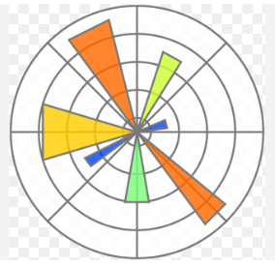
A basic Python library used to create charts and graphs.
Purpose
Creates visualizations such as:
- Line charts
- Bar charts
- Pie charts
- Histograms
Real-Life Example
Displaying monthly sales trends.
Best suitable data for a matplotlib:
Matplotlib is used to visualize numerical, categorical, and time-series data through charts and graphs.

2. Seaborn 
An advanced visualization library built on Matplotlib.
Purpose
Creates attractive and easy-to-understand graphs.
Real-Life Example
Finding relationships between customer age and spending.
Best suitable data for a seaborn:
Seaborn is used for statistical visualization of numerical, categorical, time series data with attractive and informative graphs.

Types of Data Visualization
1D Visualization (One Variable)
Uses only one column or feature.

Example
Salary Column
Salary
30000
35000
40000
Only one variable is analysed.

Pie Chart
What is it?
Shows percentage contribution.
Purpose
Displays parts of a whole.
Real-Life Example
Market Share:
- Company A = 40%
- Company B = 30%
- Company C = 20%
- Company D = 10%
Why Use Pie Chart?
Because we want to see percentage contribution.
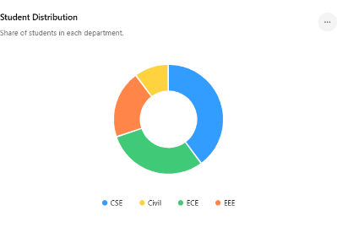
Best suitable data for a pie chart:
Pie charts are best used for categorical data that represents proportions or percentages of a whole.

Bar Chart
Compares categories.
Purpose
Compare values between groups
Real-Life Example
Sales by Department.
Department | Sales
HR | 100
IT | 250
Finance | 150
Why Use Bar Chart?
Because categories are being compared.
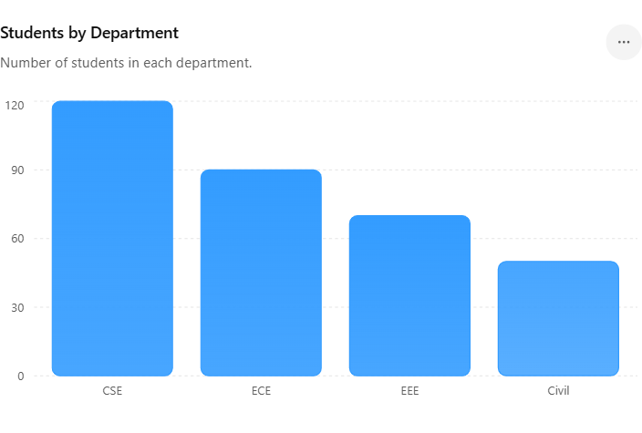
Best suitable data for a Bar chart:
Bar charts are best used to compare numerical values across different categories.

Histogram
Shows the distribution of numerical data.
Purpose
- Understand data spread
- Identify skewness
- Detect unusual patterns
Real-Life Example
Student marks distribution.
Why Use Histogram?
Because it shows how values are distributed across ranges.
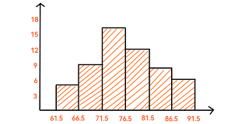
Best suitable data for a histogram:
Continuous numerical data to show data distribution and frequency.

Box Plot
Displays distribution and outliers.
Purpose
- Detect outliers
- Understand spread
- Find median
Real-Life Example
Employee salaries.
Why Use Box Plot?
Because it quickly identifies unusual values.
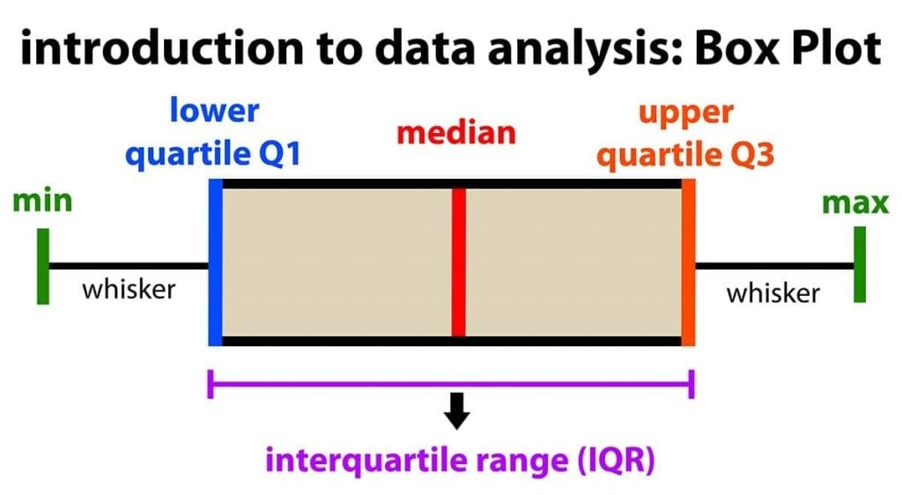
Best suitable data for a box plot:
Numerical data to identify distribution, spread, and outliers.

2D Visualization (Two Variables)
Uses two columns or features.
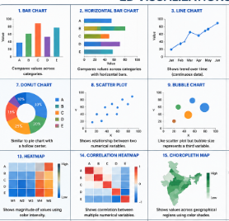
Example
Study Hours | Marks
2 | 60
4 | 75
6 | 90

Scatter Plot
Shows the relationship between two numerical variables.
Purpose
- Find correlation
- Detect trends
- Identify clusters
Real-Life Example
Study Hours vs Marks.
Why Use Scatter Plot?
Because both variables are numerical and we want to see their relationship.
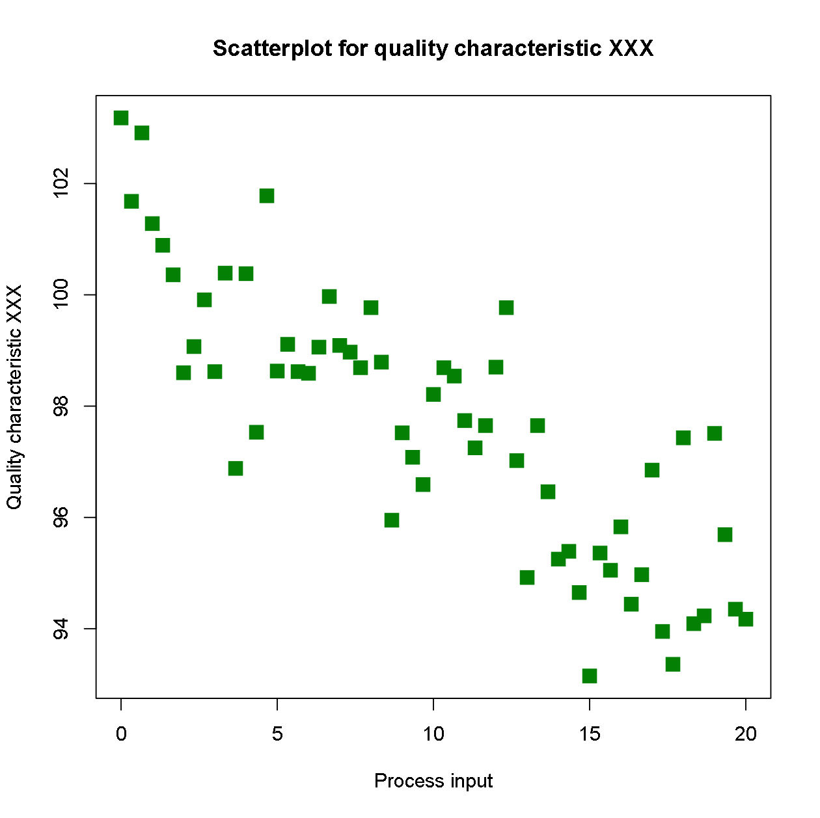
Best suitable data for a scatter plot:
Two numerical variables to analyse their relationship or correlation.

Line Chart
Shows changes over time.
Purpose
- Track growth
- Identify trends
Real-Life Example
Monthly Sales.
Why Use Line Chart?
Because time-based data is best represented using connected points.
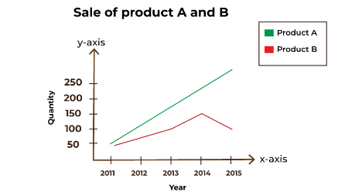
Best suitable data for a line chart:
Time-series or ordered data to show trends over time.

Correlation Heatmap
A coloured matrix showing relationships between variables.
Purpose
- Find strongly related features
- Support feature selection
Real-Life Example
Finding whether salary depends on experience.
Why Use Heatmap?
Because many variables can be compared at the same time.
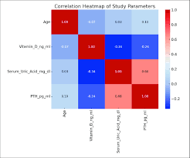
Best suitable data for a correlation heatmap:
Multiple numerical variables to show correlation between them.

3D Visualization (Three Variables)
Uses three variables together.
Example
Age | Experience | Salary
25 | 2 | 30000
30 | 5 | 50000

3D Scatter Plot
Shows relationships among three numerical variables.
Purpose
Analyse multiple features simultaneously.
Real-Life Example
Age, Experience, and Salary.
Why Use 3D Scatter Plot?
Because three numerical variables need to be visualized together.
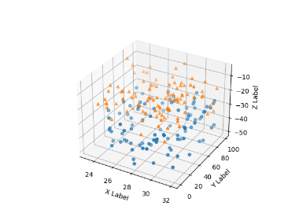
Best suitable data for a 3D scatter plot:
Three numerical variables to analyse relationships among them.
3D Bar Chart
Definition:
A 3D bar chart is a visualization that uses three dimensions to compare numerical values across two categorical variables.
Purpose:
Used to compare numerical values across two categories in a three-dimensional view.
Real-life Example:
Comparing sales of different products across multiple regions.
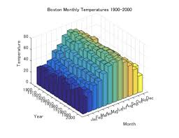 Best suitable data for a 3D bar chart:
Two categorical variables and one numerical variable.

4. Exploratory Data Analysis (EDA)
What is EDA?
EDA (Exploratory Data Analysis) is the process of understanding and exploring data before building any machine learning model.
EDA helps us answer questions such as:
- What does the data look like?
- Are there missing values?
- Are there outliers?
- Which features are important?
- Are any variables related to each other?
Purpose
- Understand the dataset
- Find patterns and trends
- Detect errors and outliers
- Discover relationships between variables
- Help select the right features for machine learning
Real-Life Example
Suppose a company wants to predict employee salaries.
Before building a model, we need to understand:
- Average salary
- Salary distribution
- Missing values
- Relationship between experience and salary
This process is called EDA.

Steps in EDA
1. Understand the Dataset
Questions to ask:
- How many rows are there?
- How many columns are there?
- What are the data types?
Purpose
Get a basic understanding of the data.

2. Check Missing Values
Purpose
Example
Name | Salary
Ravi | 30000
Sita | Blank

3. Check Duplicate Records
Purpose
Remove repeated data.
Example
Same employee entered twice.

4. Analyse Statistics
Use:
- Mean
- Median
- Mode
- Variance
- Standard Deviation
Purpose
Understand the overall behaviour of data.

5. Detect Outliers
Use:
- IQR
- Box Plot
Purpose
Find unusual values.

6. Visualize Data
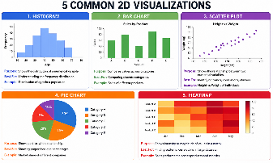
use:
- Histogram
- Bar Chart
- Scatter Plot
- Pie Chart
- Heatmap
Understand patterns quickly.

Correlation Analysis
What is Correlation?
Correlation measures how strongly two variables are related.
Purpose
Helps identify which features influence each other.
Real-Life Example
Employee Experience and Salary.
Usually:
More Experience → Higher Salary
This indicates a positive correlation.

Types of Correlation
1. Positive Correlation
When one variable increases, the other also increases.
Example
Experience ↑ → Salary ↑
Real-Life Example
More study hours usually lead to higher marks.

2. Negative Correlation
When one variable increases, the other decreases.
Example
Speed ↑ → Travel Time ↓
Real-Life Example
The faster you drive, the less time it takes to reach your destination.

3. No Correlation
No relationship exists between variables.
Example
Shoe Size and Salary.
Real-Life Example
A person's shoe size usually does not affect their income.

Correlation Coefficient
Finding values that are very different from the rest of the data.
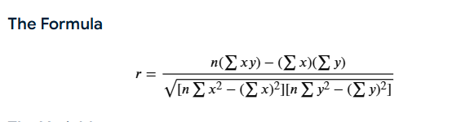
Value | Meaning
+1 | Perfect Positive Correlation
0 | No Correlation
-1 | Perfect Negative Correlation

Heatmap
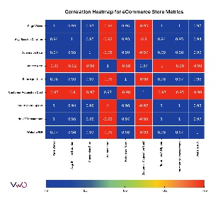
What is a Heatmap?
A heatmap is a graphical representation of correlation values using colours.
Purpose
- Visualize correlations quickly
- Identify strong relationships
- Detect redundant features
Real-Life Example
Employee Dataset:
Feature
Age
Experience
Salary
Education
A heatmap shows which variables are strongly related.

Why Use a Heatmap?
Without a heatmap:
You need to read many correlation values.
With a heatmap:
Colours immediately show strong and weak relationships.

EDA Process
- Check data types.
- Handle missing values.
- Remove duplicates.
- Detect outliers using IQR and Box Plot.
- Calculate statistics.
- Create visualizations.
- Perform correlation analysis.
- Generate heatmap.
- Select important features for machine learning

5. Time Series Data and Discrete Data
Time Series Data is data collected over a period of time at regular intervals.
In simple words:
When time (day, month, year, hour) is important, it is called Time Series Data.

Purpose
- Analyse trends over time
- Forecast future values
- Monitor business performance
- Detect seasonal patterns

Real-Life Examples
Sales Data
Month | Sales
January | 1000
February | 1200
March | 1500
Here, sales are recorded month by month.
This is Time Series Data.
Best Visualization for Time Series Data
Line Chart
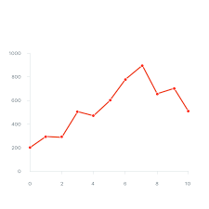
Why Use a Line Chart?
- Shows trends clearly
- Displays increase or decrease over time
- Easy to identify growth patterns
Real-Life Example
Monthly company sales.
Sales ↑ Month after Month
A line chart clearly shows this trend.

Discrete Data
What is Discrete Data?
Discrete Data consists of countable values.
In simple words:
Data that can be counted and usually has whole numbers.

Purpose
Used when counting items, people, or events.

Real-Life Examples
Number of Students
Class | Students
A | 30
B | 35
You cannot have 30.5 students.
Characteristics of Discrete Data
✔ Countable
✔ Whole Numbers
✔ Finite Values
Examples:
- Number of Customers
- Number of Products Sold
- Number of Hospital Patients

Real-Life Example
Discrete Data
Number of students = 50
You can count them.

Continuous Data
Height = 170.5 cm
Weight = 65.75 kg
These values can contain decimals.

Visualization for Discrete Data
Bar Chart
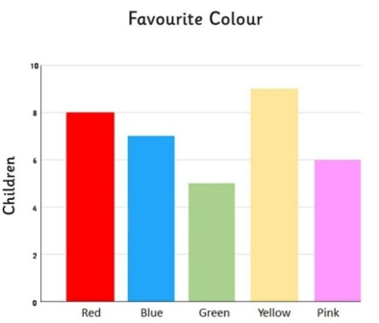
Why Use Bar Chart?
- Easy comparison between categories
- Best for count-based data
Real-Life Example
Students in different classes.
Class | Students
A | 30
B | 40
C | 35
A bar chart clearly compares the counts.
6) Different Types of Machine Learning Models
Machine Learning models are mainly divided into 3 types:
1. Supervised Learning
- Learns from labelled data (input + correct output).
- Used for prediction.
In supervised we have Regression and Classification
Regression-It continuously predicts a value
Ex-House price
Regression Algorithms
1. Linear Regression
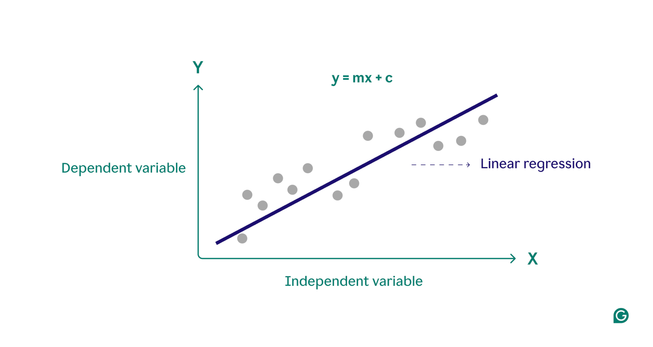
Predicts a continuous value using a straight-line relationship.
Advantage: Simple and easy to understand.
Because it uses a straight-line relationship between input and output, making the results easy to interpret.
Disadvantage: Does not work well for complex relationships.
Because it assumes a straight-line relationship, while many real-world problems have curved or nonlinear patterns.
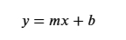
Important Linear Regression Parameters
1. fit_intercept
What is it?
Determines whether the model should calculate the intercept (constant value) of the regression line.
Purpose
Helps the model find a better-fitting line when the data does not start from zero.
Before Parameter
Suppose the data is:
Hours Studied | Marks
1 | 15
2 | 25
3 | 35
The relationship is:
Marks = 10 × Hours + 5
Notice that when Hours = 0, Marks = 5.
After Parameter
fit_intercept = True
- Model learns the +5 automatically.
- Equation becomes:
Marks = 10 × Hours + 5
fit_intercept = False
- Model forces the line through (0,0).
- Equation becomes:
Marks = 10 × Hours
When to Use
Use True in most real-world problems.
2. positive
What is it?
Forces all coefficients (weights) to be positive.
Purpose
Used when negative relationships do not make practical sense.
Before Parameter
Example:
Advertising Budget | Sales
1000 | 5000
2000 | 8000
3000 | 12000
Normally, increasing advertising should increase sales.
After Parameter
positive = False
- Coefficient can be positive or negative.
- Example:
Sales = -2 × Budget + 10000
This may not make business sense.
positive = True
- Coefficient must be positive.
- Example:
Sales = 2 × Budget + 1000
When to Use
When domain knowledge says the relationship should only be positive.
3. copy_X
What is it?
Determines whether the original dataset should be copied before training.
Purpose
Protects the original data from modifications.
Before Parameter
Original Dataset:
Age
20
30
40
After Parameter
copy_X = True
- Original data remains unchanged.
copy_X = False
- Model may modify data internally to save memory.
When to Use
Usually keep it enabled because preserving original data is safer.
Important Outputs After Training
1. Coefficient (Slope)
What is it?
Shows how much the target changes when a feature increases by one unit.
Example
Experience (Years) | Salary
1 | 30,000
2 | 35,000
3 | 40,000
Coefficient = 5000
Interpretation
For every additional year of experience:
Salary increases by ₹5,000.
2. Intercept
What is it?
The predicted value when all input features are zero.
Example
Equation:
Salary = 5000 × Experience + 25000
Intercept = 25,000
Interpretation
When Experience = 0:
Predicted Salary = ₹25,000
3. R² Score
What is it?
Measures how well the regression line explains the data.
Example
R² = 0.90
Interpretation
The model explains 90% of the variation in the target variable.
R² Value | Meaning
1.0 | Perfect Fit
0.9 | Excellent
0.8 | Good
0.5 | Moderate
0.0 | Poor
4. Residuals (Errors)
What is it?
Difference between actual value and predicted value.
Example
Actual | Predicted
100 | 95
Residual = 100 − 95 = 5
Purpose
Helps measure prediction accuracy.
Smaller residuals = Better model.2. Logistic Regression
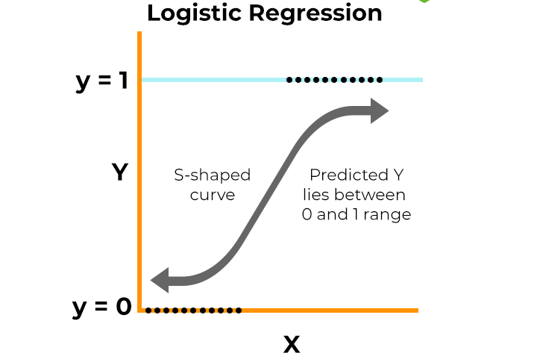
Predicts the probability of a category (Yes/No).
Advantage: Fast and easy to implement.
Because it uses simple calculations, trains quickly, and does not require complicated setup or tuning.
Disadvantage: Struggles with complex data patterns.
Because it is designed for simple relationships and cannot effectively learn complicated or nonlinear patterns in the data.

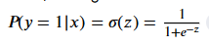
Important Parameters
1. penalty
What is it?
Controls how the model handles complex relationships and prevents overfitting.
Purpose
Helps the model generalize better on new data.
Before Parameter
The model may fit training data too closely and perform poorly on new data.
After Parameter
penalty = l2 (Default)
- Keeps coefficients smaller.
- Reduces overfitting.
penalty = l1
- Removes less important features.
- Useful for feature selection.
Example
Age | Income | Loan Approved
25 | 30000 | Yes
45 | 80000 | Yes
L1 may remove unnecessary features and keep only important ones.
2. C
What is it?
Controls the strength of regularization.
Purpose
Balances model complexity and accuracy.
Before Parameter
The model may overfit or underfit.
After Parameter
Small C (0.1)
- Strong regularization.
- Simpler model.
Large C (100)
- Weak regularization.
- More complex model.
Example
C Value | Result
0.1 | Simpler model
1 | Balanced
100 | Complex model
3. max_iter
What is it?
Maximum number of iterations the algorithm can use to find the best solution.
Purpose
Ensures the model has enough attempts to learn.
Before Parameter
Model may stop before finding the best coefficients.
After Parameter
max_iter = 100
- Standard learning.
max_iter = 1000
- Gives more time to converge.
Example
Large datasets often require higher iterations.

4. solver
What is it?
The optimization method used to train the model.
Purpose
Helps the model find the best coefficients efficiently.
Common Solvers
Solver | Purpose
lbfgs | Default, works well for most datasets
liblinear | Good for small datasets
saga | Good for large datasets
newton-cg | Efficient for multiclass problems

5. class_weight
What is it?
Gives more importance to minority classes.
Purpose
Handles imbalanced datasets.
Before Parameter
Fraud Cases | Normal Cases
50 | 5000
The model may ignore fraud cases.
After Parameter
class_weight = balanced
The model pays more attention to fraud cases.

Important Outputs After Training

1. Coefficients
What is it?
Shows how much each feature influences the prediction.
Example
Feature | Coefficient
Salary | +2.5
Loan Amount | -1.8
Interpretation
- Positive coefficient → Increases probability of class 1.
- Negative coefficient → Decreases probability of class 1.

2. Intercept
What is it?
The baseline prediction when all features are zero.
Example
Intercept = 0.8
This is the starting point before considering other features.

3. Predicted Probability
What is it?
Probability that a record belongs to a class.
Example
Customer | Probability
A | 0.90
B | 0.20
Interpretation:
- 0.90 → 90% chance of Yes
- 0.20 → 20% chance of Yes

4. Accuracy
What is it?
Percentage of correct predictions.
Example
90 correct predictions out of 100
Accuracy = 90%

5. Confusion Matrix
What is it?
Shows correct and incorrect classifications.
Actual / Predicted | Yes | No
Yes | True Positive | False Negative
No | False Positive | True Negative
Purpose
Provides detailed performance analysis.

3. Polynomial Regression
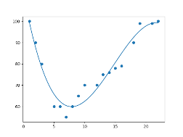
Fits a curved line to model complex relationships.
Advantage: Can capture non-linear patterns.
Reason: Because it can learn curved and complex relationships that are commonly found in real-world data.
Disadvantage: Can easily overfit the data.
Because it may learn unnecessary details and noise from the training data, which reduces its performance on new data.
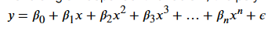
Important parameters in polynomial regression
1. degree
What is it?
Determines the highest power of the feature.
Purpose
Controls the complexity of the curve.
Before Parameter
Original Feature:
x
1
2
3
Only:
x
After Parameter
degree = 2
x | x²
1 | 1
2 | 4
3 | 9
Model can learn curved relationships.

degree = 3
x | x² | x³
1 | 1 | 1
2 | 4 | 8
3 | 9 | 27
Model can learn more complex curves.
Impact
Degree | Result
1 | Straight Line
2 | Simple Curve
3 | More Flexible Curve
Very High | Risk of Overfitting

2. include_bias
What is it?
Adds a column containing only 1s.
Purpose
Helps the model learn the intercept.
Before Parameter
x
1
2
3
After Parameter
include_bias = True
Bias | x | x²
1 | 1 | 1
1 | 2 | 4
1 | 3 | 9
Extra bias column is added.

include_bias = False
x | x²
1 | 1
2 | 4
3 | 9
No extra bias column.
Practical Use
Usually set to False when the regression model already handles the intercept.

3. interaction_only
What is it?
Creates only interaction terms between features.
Purpose
Reduces the number of generated polynomial features.
Before Parameter
Age | Salary
25 | 30000

After Parameter
interaction_only = False
Generated Features:
- Age
- Salary
- Age²
- Salary²
- Age × Salary
Many new features are created.

interaction_only = True
Generated Features:
- Age
- Salary
- Age × Salary
Only interaction terms are created.
Benefit
- Fewer features
- Faster training
- Less overfitting

4. Decision Tree
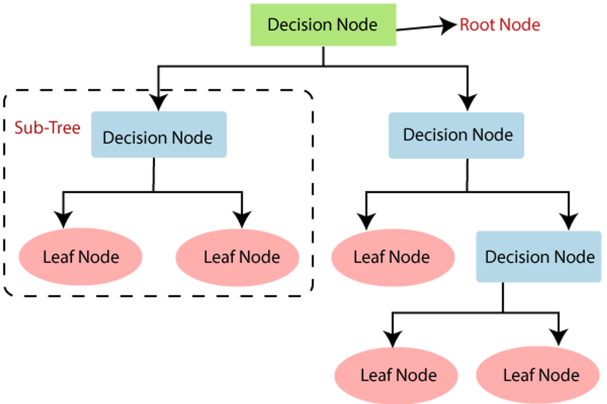
Makes predictions using a series of if-else rules.
Advantage: Easy to understand and visualize.
Reason: Because the model follows a tree structure where each decision can be clearly seen and explained, making it easy to understand how predictions are made.
Disadvantage: Can overfit the training data.
Because the tree may learn unnecessary details and noise from the training data, causing poor performance on new data.
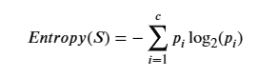

5. Random Forest
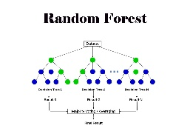
Combines many decision trees for better predictions.
Advantage: More accurate and less overfitting.
Reason: Because it combines the predictions of multiple Decision Trees, reducing errors and improving generalization.
Disadvantage: Slower and harder to interpret.
Reason: Because it uses many trees, which increases computation time and makes the decision-making process difficult to understand.
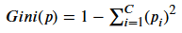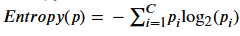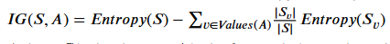
1. n_estimators
Purpose
Controls how many Decision Trees are created.
Example
Dataset:
Age | Purchased
20 | No
35 | Yes
Before
n_estimators = 10
- Only 10 trees vote.
After
n_estimators = 100
- 100 trees vote.
Result:
- More stable predictions.
- Better accuracy.
- More training time.

2. max_depth
Purpose
Controls the maximum depth of each tree.
Example
max_depth = 3
- Small trees.
- Less overfitting.
max_depth = 20
- Large trees.
- Can memorize data.
Result:
- Helps balance accuracy and overfitting.

3. min_samples_split
Purpose
Minimum records needed before splitting a node.
Example
Node contains:
Records
5
min_samples_split = 2
- Split allowed.
min_samples_split = 10
- Split not allowed.
Result:
- Prevents unnecessary branches.

4. min_samples_leaf
Purpose
Minimum records required in a final leaf.
Example
min_samples_leaf = 1
- A leaf can contain only one record.
min_samples_leaf = 5
- Every leaf must contain at least 5 records.
Result:
- More reliable predictions.
- Reduced overfitting.

5. max_features
Purpose
Number of features checked while creating a split.
Example
Features:
- Age
- Salary
- Experience
- Education
- City
max_features = 5
- Uses all features.
max_features = 2
- Uses only 2 random features.
Result:
- Trees become different from each other.
- Better overall performance.

6. bootstrap
Purpose
Controls whether each tree gets a random sample of the data.
Example
Dataset:
Records
1000
bootstrap = True
Tree 1 → Random sample of records
Tree 2 → Different random sample
Tree 3 → Another random sample
Result:
- Trees learn different patterns.
- Better generalization.
bootstrap = False
All trees use the same dataset.
Result:
- Less diversity among trees.

6. XG Boost
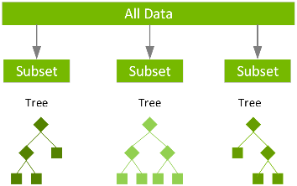
Builds trees sequentially to improve prediction accuracy.
Advantage: Very high performance and accuracy.
Reason: Because it continuously learns from previous mistakes and improves the model step by step, leading to highly accurate predictions.
Disadvantage: More complex and slower to train.
Reason: Because it has many parameters to tune and builds trees sequentially, which increases training time and complexity.
1. n_estimators
Purpose
Controls the number of trees built.
Example
n_estimators = 50
- 50 trees learn from the data.
n_estimators = 500
- 500 trees learn from the data.
Impact
Value | Result
Small | Faster training
Large | Better learning but slower

2. max_depth
Purpose
Controls the maximum depth of each tree.
Example
max_depth = 3
- Simple trees.
- Less overfitting.
max_depth = 10
- Complex trees.
- Can memorize training data.
Impact
Value | Result
Small | Better generalization
Large | Higher risk of overfitting

3. learning_rate
Purpose
Controls how much each tree contributes to the final prediction.
Example
Suppose the model prediction error is 100.
learning_rate = 0.3
- Corrects errors quickly.
learning_rate = 0.01
- Corrects errors slowly and carefully.
Impact
Value | Result
High | Faster learning
Low | More stable learning

4. min_child_weight
Purpose
Minimum amount of data required in a child node befor e creating a split.
Example
Node contains very few records.
min_child_weight = 1
- Split is allowed easily.
min_child_weight = 10
- Split occurs only if enough data exists.
Impact
- Higher value → Less overfitting.
- Lower value → More detailed learning.

5. subsample
Purpose
Controls the percentage of rows used to build each tree.
Example
Dataset contains 10,000 rows.
subsample = 1.0
- Uses all 10,000 rows.
subsample = 0.8
- Uses only 8,000 rows randomly.
Impact
- Reduces overfitting.
- Makes trees more diverse.

6. colsample_bytree
Purpose
Controls the percentage of features used while building a tree.
Example
Features:
- Age
- Salary
- Experience
- Education
- City
Total = 5 features
colsample_bytree = 1.0
- Uses all 5 features.
colsample_bytree = 0.6
- Uses only 3 random features.
Impact
- Reduces overfitting.
- Improves generalization.

7. gamma
Purpose
Minimum improvement required before creating a new split.
Example
A split improves accuracy by only a tiny amount.
gamma = 0
- Split is accepted.
gamma = 5
- Split occurs only if improvement is significant.
Impact
- Higher gamma → Simpler model.
- Lower gamma → More complex model.

7. SVR (Support Vector Regression)
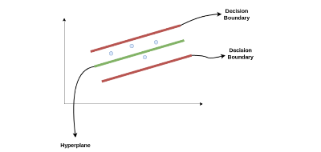
Predicts continuous values by finding the best boundary.
Advantage: Works well with complex data.
Reason: Because it can learn nonlinear and complex relationships using kernel functions.
Disadvantage: Slow for large datasets.
Reason: Because it requires many calculations, which increase training time and memory usage as the dataset grows.

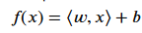
1. C
Purpose
Controls how much the model cares about prediction errors.
Example
Predicting House Prices
Actual Price | Predicted Price
₹10,00,000 | ₹9,90,000
Error = ₹10,000
Impact
C = 1
- Allows some errors.
- Simpler model.
C = 100
- Tries very hard to reduce errors.
- More complex model.
Value | Result
Small C | Simpler model
Large C | More accurate on training data but may overfit

2. kernel
Purpose
Determines the type of relationship SVR should learn from the data.
Example
Study Hours | Marks
1 | 20
2 | 35
3 | 60
4 | 95
The relationship is curved, not straight.
Common Values
Kernel | Use
linear | Straight-line relationship
rbf | Curved/nonlinear relationship
poly | Polynomial relationship
sigmoid | Neural-network-like behavior
Most Common
rbf is used in most real-world projects.

3. gamma
Purpose
Controls how much influence each data point has.
Example
Dataset:
x | y
1 | 10
2 | 20
3 | 30
Impact
Small gamma
- Looks at a larger area of data.
- Smoother predictions.
Large gamma
- Focuses heavily on nearby points.
- Can overfit.
Value | Result
Small | Smooth curve
Large | Complex curve

4. epsilon (ε)
Purpose
Defines the acceptable error margin.
Example
Actual Value = 100
Predicted Value = 104
Error = 4
Impact
epsilon = 5
- Error of 4 is acceptable.
- No penalty.
epsilon = 2
- Error of 4 is not acceptable.
- Penalty applied.
Value | Result
Small ε | Higher accuracy
Large ε | More tolerance to errors

5. degree
Purpose
Used only when kernel = poly.
Controls the polynomial complexity.
Example
degree = 2
- Learns quadratic relationships.
degree = 3
- Learns cubic relationships.
Impact
Degree | Result
2 | Simple curve
3 | More flexible curve
High Degree | Risk of overfitting

Classification Algorithm
1. Logistic Regression
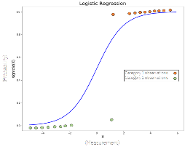
Classifies data into categories like Yes/No.
Advantage: Fast and simple.
Reason: Because it uses a simple mathematical approach, trains quickly, and is easy to understand and implement.
Disadvantage: Not good for highly complex data.
Reason: Because it works best with simple relationships and may not capture complex or nonlinear patterns in the data
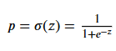
2. Decision Tree
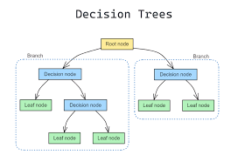
Classifies data using if-else decision rules.
Advantage: Easy to understand.
Reason: Because the tree structure clearly shows how decisions are made, making the model easy to visualize and explain.
Disadvantage: Can overfit easily.
Reason: Because it may learn unnecessary details and noise from the training data, reducing its performance on new data.
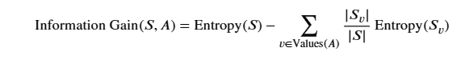
1. max_depth
Purpose
Controls how many levels the tree can grow.
Example
Dataset:
Age | Purchased
20 | No
25 | No
35 | Yes
45 | Yes
max_depth = 2
- Tree creates only a few splits.
- Simpler model.
max_depth = 20
- Tree creates many splits.
- Can memorize training data (overfitting).

2. min_samples_split
Purpose
Minimum number of records required before a node can be split.
Example
Node contains:
Records
4
min_samples_split = 2
- Node can split.
min_samples_split = 10
- Node cannot split.
- Model waits for more data.

3. min_samples_leaf
Purpose
Minimum number of records that must remain in each final leaf.
Example
Dataset:
Customer
A
B
C
D
E
min_samples_leaf = 1
- A leaf can contain only one customer.
min_samples_leaf = 3
- Each leaf must have at least 3 customers.
Result:
- More reliable predictions.
- Less overfitting.

4. max_features
Purpose
Controls how many features are checked while creating a split.
Example
Features:
- Age
- Salary
- Experience
- Education
- Location
max_features = 5
- Uses all features.
max_features = 2
- Uses only 2 features at each split.
Result:
- Faster training.
- Less overfitting.

5. criterion
Purpose
Determines how the model decides the best split.
Common Values
Value | Meaning
Gini | Measures impurity
Entropy | Measures information gain
Example
Marks | Selected
90 | Yes
40 | No
The criterion helps determine the best question to separate "Yes" and "No".

3. SVM (Support Vector Machine)
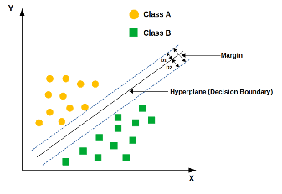
Finds the best boundary to separate classes.
Advantage: Works well with high-dimensional data.
Reason: Because it can effectively handle datasets with many features and still find an accurate decision boundary.
Disadvantage: Slow on large datasets.
Reason: Because it requires complex calculations, which increase training time as the dataset size grows.
1. C
Purpose
Controls how much the model penalizes misclassified data points.
Example
Student Marks | Result
90 | Pass
85 | Pass
40 | Fail
Impact
C = 1
- Allows some classification mistakes.
- Better generalization.
C = 100
- Tries to classify every point correctly.
- Higher risk of overfitting.
Value | Result
Small C | Simpler boundary
Large C | Complex boundary

2. kernel
Purpose
Determines the type of decision boundary.
Example
Dataset:
Age | Purchased
20 | No
25 | No
40 | Yes
45 | Yes
Common Values
Kernel | Purpose
linear | Straight-line seperation
rbf | Curved separation
poly | Polynomial boundary
sigmoid | Neural-network-like boundary
Most Common
RBF (Radial Basis Function) is widely used because it handles nonlinear data well.

3. gamma
Purpose
Controls how much influence each training point has on the decision boundary.
Example
Small gamma
- Considers many nearby points.
- Smooth boundary.
Large gamma
- Focuses on very close points.
- Complex boundary.
Impact
Value | Result
Small Gamma | Smooth decision boundary
Large Gamma | Complex decision boundary

4. degree
Purpose
Used only when kernel = poly.
Controls the complexity of the polynomial boundary.
Example
degree = 2
- Simple curved boundary.
degree = 4
- More complex boundary.
Impact
Degree | Result
Low | Simpler model
High | More flexible model

5. class_weight
Purpose
Handles imbalanced datasets.
Example
Class | Records
Non-Fraud | 950
Fraud | 50
Without class weights:
- Model focuses on Non-Fraud cases.
With class_weight = balanced:
- Model gives more importance to Fraud cases.
Benefit
- Better minority-class prediction.
- Useful in fraud detection and medical diagnosis.

4. Naive Bayes
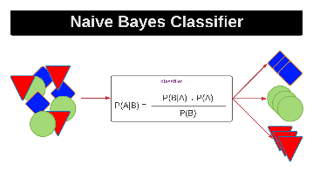
Uses probability to classify data.
Advantage: Very fast and works well with text data.
Reason: Because it uses simple probability calculations and can efficiently analyze large amounts of text data.
Disadvantage: Assumes features are independent.
Reason: Because it treats each feature as unrelated to the others, which is often not true in real-world datasets.

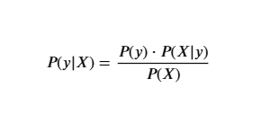
1. var_smoothing (Gaussian Naive Bayes)
Purpose
Adds a small value to the variance to avoid division-by-zero errors and make calculations more stable.
Example
Dataset:
Age | Disease
25 | Yes
25 | Yes
25 | Yes
Variance becomes very close to zero.
Impact
Small var_smoothing
- Model closely follows the data.
Large var_smoothing
- Model becomes more stable.
- Reduces sensitivity to small variations.
Value | Result
Small | More sensitive
Large | More stable

2. alpha (Multinomial & Bernoulli Naive Bayes)
Purpose
Controls smoothing of probabilities.
Example
Training Data:
Word | Spam Count
Win | 50
Lottery | 0
Without smoothing:
Probability of "Lottery" = 0
This can create prediction problems.
Impact
alpha = 0
- No smoothing.
- Zero probabilities possible.
alpha = 1
- Applies smoothing.
- Avoids zero probabilities.
Value | Result
Small | Less smoothing
Large | More smoothing

3. fit_prior
Purpose
Determines whether class probabilities should be learned from the dataset.
Example
Dataset:
Class | Count
Spam | 200
Not Spam | 800
Impact
fit_prior = True
- Learns class distribution from data.
- Uses 20% Spam and 80% Not Spam.
fit_prior = False
- Treats all classes equally.
Setting | Result
True | Uses actual class distribution
False | Assumes equal class probability

4. class_prior
Purpose
Allows manually setting class probabilities.
Example
Fraud Detection
Class | Probability
Fraud | 0.4
Non-Fraud | 0.6
Instead of learning from data, you provide the probabilities.
Benefit
Useful when business knowledge is available.

5. KNN (K-Nearest Neighbours)
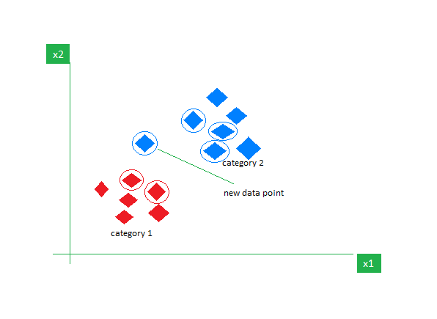
Classifies based on the nearest data points.
Advantage: Simple and easy to use.
Reason: Because it makes predictions using the nearest data points and does not require a complex training process.
Disadvantage: Slow for large datasets.
Reason: Because it must compare the new data point with all training data points, which takes more time as the dataset size increases.
Euclidean Formula
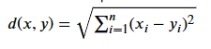
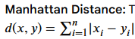
1. n_neighbours (K)
Purpose
Controls how many nearest neighbours are used to make a prediction.
Example
Customer | Purchased
A | Yes
B | Yes
C | No
D | Yes
E | No
Impact
K = 3
- Uses 3 nearest neighbours.
- Prediction based on majority vote of 3 neighbours.
K = 5
- Uses 5 nearest neighbours.
- More stable prediction.
Value | Result
Small K | Sensitive to noise
Large K | More stable but may miss patterns

2. weights
Purpose
Determines how neighbours contribute to the prediction.
Example
Suppose nearest neighbours are:
Neighbour | Distance
A | 1
B | 2
C | 10
Impact
weights = uniform
- All neighbours have equal importance
weights = distance
- Closer neighbours get more importance.
Setting | Result
uniform | Equal voting
distance | Nearby points influence more

3. metric
Purpose
Determines how distance is calculated between data points.
Common Metrics
Metric | Purpose
euclidean | Straight line distance
manhattan | Grid/block distance
minkowski | Generalized distance
Example
Points:
- A(2,3)
- B(5,7)
The metric decides how distance is measured between them.

4. p
Purpose
Used with Minkowski distance to define the distance type.
Impact
p Value | Distance Type
1 | Manhattan Distance
2 | Euclidean Distance
Example
p = 1
- Measures distance by horizontal and vertical movement.
p = 2
- Measures direct straight-line distance.

5. algorithm
Purpose
Controls how neighbours are searched.
Common Values
Algorithm | Purpose
auto | Automatically selects best method
ball_tree | Faster for large datasets
kd_tree | Efficient for low-dimensional data
brute | Checks all points
Impact
Affects speed, not prediction logic

Unsupervised Learning
What is Unsupervised Learning?
Unsupervised Learning is a type of Machine Learning that works with data that has no labels or answers. The algorithm studies the data and finds patterns or groups by itself.
The main purpose of Unsupervised Learning is to:
- Find hidden patterns in data.
- Group similar data together.
- Understand large amounts of data easily.
- Detect unusual or abnormal data.
- Reduce the number of features in a dataset.

Example
Customer Grouping
A shopping company has customer data but does not know which customers are similar.
The algorithm analyses the data and creates groups such as:
- Frequent buyers
- High-spending customers
- Occasional buyers
This helps the company understand its customers better.

Algorithms Included
Clustering Algorithms
Used to group similar data together.
- K-Means
- Hierarchical Clustering
- DBSCAN

Key Points
- Uses unlabelled data.
- No correct answers are provided.
- Finds patterns automatically.
- Groups similar data together.
- Useful for customer segmentation and data analysis

Reinforcement Learning
What is Reinforcement Learning?
Reinforcement Learning is a type of Machine Learning where an agent learns by interacting with an environment. The agent takes actions and receives rewards or penalties based on its actions. Over time, it learns the best actions to maximize rewards.

Purpose
The main purpose of Reinforcement Learning is to:
- Learn the best action to take in a situation.
- Maximize rewards over time.
- Make better decisions through experience.
- Solve complex decision-making problems.

Example
Self-Driving Car
A self-driving car learns how to drive safely.
- Safe driving → Reward
- Reaching destination → Reward
- Hitting an obstacle → Penalty
By receiving rewards and penalties, the car learns the best driving behaviour.

Algorithms Included
- Q-Learning
- SARSA
- Deep Q-Network (DQN)
- Policy Gradient
- Actor-Critic

Key Points
- Learns through trial and error.
- Uses rewards and penalties.
- Improves performance with experience.
- Focuses on making the best decisions.
- Commonly used in robotics, gaming, and self-driving cars.

7) Algorithm Performance Metrics
After building a Machine Learning model, we need to check how well it performs. This is called Model Evaluation.

Regression Metrics
(Used when the output is a number, like house price, salary, temperature)
1. MAE (Mean Absolute Error)
Measures the average difference between actual and predicted values.
Example:
Actual Salary = ₹50,000
Predicted Salary = ₹48,000
Error = 2,000
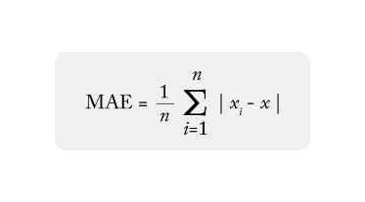
Good Model: Lower MAE

2. MSE (Mean Squared Error)
Measures the average squared error.
Example:
Error = 10
MSE = 10² = 100
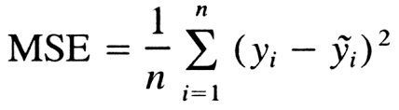
Good Model: Lower MSE

3. RMSE (Root Mean Squared Error)
Square root of MSE.
Example:
If RMSE = 5
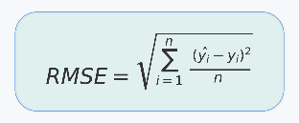
The model is wrong by about 5 units on average.
Good Model: Lower RMSE

4. R² Score (R-Squared)
Measures how much variation in the data is explained by the model.
Example:
R² = 0.90
The model explains 90% of the data.
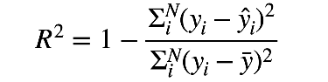
Good Model: Closer to 1

5. Coefficient of Determination (COD)
Another name for R² Score.
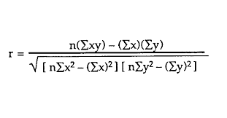
Good Model: Closer to 1

Classification Metrics
(Used when the output is a category, like Spam/Not Spam, Yes/No)
1. Confusion Matrix
A table that compares actual values with predicted values.

Actual | Predicted
Yes | Yes
Yes | No
No | Yes
No | No
Purpose: Understand model performance.
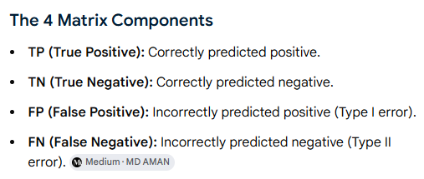

2. Accuracy
Percentage of correct predictions.
Example:
95 correct out of 100
Accuracy = 95%
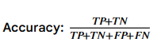
Good Model: Higher Accuracy

3. Precision
Out of all positive predictions, how many were actually positive?
Example:
Email marked as Spam.
Precision checks how many are truly spam.
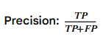
Good Model: Higher Precision

4. Recall
Out of all actual positives, how many did the model find?
Example:
Out of 100 spam emails, the model found 90.
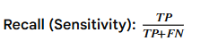
Recall = 90%
Good Model: Higher Recall

5. F1 Score
Combination of Precision and Recall.
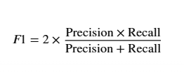
Example:
Useful when both false positives and false negatives matter.
Good Model: Higher F1 Score

Phosphoric Acid Plant(PAP) Prediction of Process Parameters
1. Project Objective
The objective of this project is to predict important PAP process parameters using machine learning models.
Target Parameters:
- Free Acid
- Filter SPG
- Slurry SPG
- No 1 Filtrate %P2O5
- No 1 Filtrate Sp Gr
- No 1 Filtrate FREEACID
- Gypsum TP2O5 Loss
The main focus of this study is to understand how different machine learning models behave and identify the best model for prediction.

2. Dataset Understanding
Total Rows: 10850
Total Columns: 51
Target Columns: 7
Input Feature Columns: 44
During preprocessing, object and datetime columns were converted into numerical format so that machine learning models could use them.

3. Understanding R² Score
R² Score indicates how much variation in the target parameter can be explained by the model.
Example:
R² = 0.96
This means:
The model explains approximately 96% of the variation in the target parameter.
Higher R² generally indicates better prediction performance.

4. Train Accuracy vs Test Accuracy
Train Accuracy:
Performance on data already seen by the model.
Test Accuracy:
Performance on unseen data.
Example:
Train R² = 0.95
Test R² = 0.93
Interpretation:
The model generalizes well.
Example:
Train R² = 1.00
Test R² = 0.40
Interpretation:
The model is overfitting.

5. Linear Regression Investigation
Purpose:
To check whether a simple linear relationship exists between process variables and Free Acid.
Result:
Train R² = 0.2941
Test R² = 0.2426
Observation:
Both train and test scores were low.
Conclusion:
Linear Regression underfitted the PAP process data and could not capture the underlying process behaviour.

6. Ridge Regression
Parameter Studied:
Alpha
Values Tested:
0.001
0.01
0.1
1
10
100
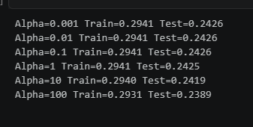
Observation:
Changing alpha had very little impact on model performance.
When I set alpha value to 0.001 the train and test accuracy remained same until the alpha value 0.1 then when I set the alpha value as 1 then the train and test accuracy started to decrease gradually.
Conclusion:
The problem was not overfitting. The model was unable to learn the complex process relationships.

7. Lasso Regression
Parameter Studied:
Alpha
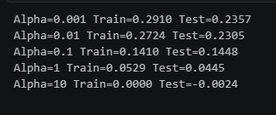
Observation:
As alpha increased, model performance decreased.
For each alpha value I increased the train and test accuracy started falling down to 0.
At high alpha values, the model removed too much information and prediction accuracy dropped significantly.
Conclusion:
Large alpha values caused severe underfitting.

8. Elastic Net Regression
Parameters Studied:
Alpha
L1 Ratio
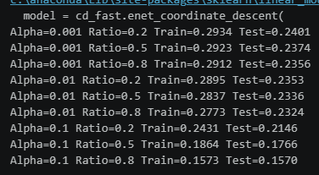
Observation:
Elastic Net behaved similarly to Ridge and Lasso.
When I improved the alpha and ratio values the train and the test accuracy ended up decreasing
No major improvement was observed.
Conclusion:
Combining Ridge and Lasso regularization did not solve the underlying problem.

9. Polynomial Regression
Purpose:
To check whether Free Acid follows a non-linear relationship.
Degree Tested:
1
2
3
Results:
Degree 1:
Train R² = 0.2941
Test R² = 0.2426
Degree 2:
Train R² = 0.8743
Test R² = -1.9924
Degree 3:
Train R² = 1.0000
Test R² = -1707.7489
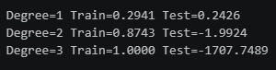
Observation:
Increasing degree increased training accuracy but significantly reduced test accuracy.
When I increased the degree value the train data has increased but the test data has descreased which led to severe overfitting that means when that model got the unseen data it couldn’t learn meaning full patterns and give accurate predictions
Conclusion:
The model memorized training data and failed to generalize.
This is called overfitting.

10. Decision Tree Investigation
Main Idea:
Decision Tree complexity is controlled using parameters.
A. Max Depth
Question:
What happens when depth increases?
Depths Tested:
2
5
10
20
50
100
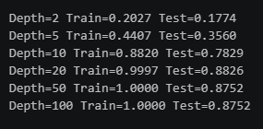
Best Result:
Depth = 20
Test R² = 0.8826
Observation:
When I increased the depth of the decision tree the train and test accuracy have been increased and improved the model performance , depth 20 is the best optimum depth where it gives the best test accuracy(0.8826) this means that the model can explain 88% of variations or changes in the target parameters.
Small depth caused underfitting.
Large depth caused overfitting.
Depth 20 provided the best balance.

B. Max Leaf Nodes
A leaf node is a node which doesn’t have child nodes
Leaf Nodes Tested:
5
10
20
50
100
200
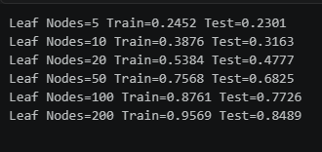
Best Result:
200 Leaf Nodes
Test R² = 0.8489
Observation:
I started increasing leaf nodes from 5 to 200 , the best optimum lead node is 200, where it gives the train accuracy (0.84) which means it can explain 84% of the variations in the target parameters.
Increasing leaf nodes improved model learning and prediction accuracy.

C. Min Samples Leaf
Values Tested:
1
2
5
10
20
50
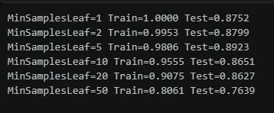
Best Result:
Min Samples Leaf = 5
Test R² = 0.8923
Observation:
When I started to increase the min samples leaf the train accuracy started to decrease but the test accuracy values are somewhat fluctuating ,the best optimum min samples leaf is 5 and its test accuracy is 0.89 means it can explain 89% of the changes in the Target parameters.
Very small values increased complexity.
Very large values simplified the tree.
Value 5 produced the best balance.

11. Random Forest Investigation
Main Parameter:
Number of Trees (n_estimators)
Values Tested:
2
5
10
20
50
100
200
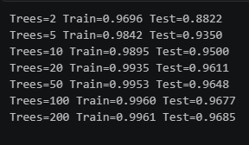
Best Result:
200 Trees
Test R² = 0.9685
Observation:
By increasing the tress the train and test accuracy has been increasing it means that the random forest model is performing well, the best optimum tree is 200 the test accuracy value is 0.96 that means it can explain 96% of the variations in the target parameters and when the random forest model receives the unseen data it can generalize well (The ability to perform well on the unseen data) and can learn meaning full patterns and give accurate predictions
Increasing the number of trees improved both train and test performance.
After 100 trees, improvement became very small.
Conclusion:
Random Forest achieved the best overall performance.

12. Understanding Underfitting
Definition:
Model is too simple.
Characteristics:
Low Train Accuracy
Low Test Accuracy
Example:
Linear Regression

13. Understanding Overfitting
Definition:
Model memorizing the training data
Characteristics:
Very High Train Accuracy
Low Test Accuracy
Example:
Polynomial Degree 3
Train R² = 1.00
Test R² = -1707.75

14. Understanding Generalization
Definition:
Ability to perform well on unseen data.
Example:
Random Forest
Train R² = 0.9961
Test R² = 0.9685
This indicates excellent generalization.

15. Final Model Comparison
Linear Regression:
0.2426
Ridge Regression:
0.2426
Lasso Regression:
0.2357
Elastic Net:
0.2401
Polynomial Regression:
Failed due to overfitting
Decision Tree:
0.8923
Random Forest:
0.9685

16. Final Conclusion
Among all tested models, Random Forest produced the highest prediction accuracy for Free Acid.
Linear models failed to capture the complex process relationships.
Decision Tree significantly improved performance by learning non-linear patterns.
Random Forest further improved stability and prediction accuracy by combining multiple decision trees.
The study demonstrated that model parameters play a critical role in balancing learning capability and generalization performance.
The final recommended model for PAP Free Acid prediction is Random Forest.

Analysis of Random Forest Results
The Random Forest model was trained to predict PAP Free Acid using the selected process variables. To understand how the model makes predictions, the model was analyzed using a decision tree visualization, feature importance analysis, and SHAP (SHapley Additive exPlanations). These analyses provide insights into the influence of different process parameters on the predicted Free Acid value.
The obtained results demonstrate that the Random Forest model successfully captures the nonlinear relationships among the industrial process variables and provides meaningful interpretations of the prediction process.
Decision Tree Analysis
The root node begins with HBF Air Support, indicating that this parameter contributes the highest reduction in prediction error. As the tree grows deeper, the model splits the data using parameters such as Solids %, Slurry Specific Gravity, Filtrate Specific Gravity, Product Acid, Cake Wash Flow, Digester Temperature, Throughput, and LLFC Vacuum.
These hierarchical splits indicate that the Random Forest model learns complex nonlinear relationships between multiple process variables instead of relying on a single parameter. Every split reduces the prediction error and improves the overall accuracy of the model.
The decision tree also illustrates that several variables work together to determine the final Free Acid prediction, which reflects the complexity of the industrial process.
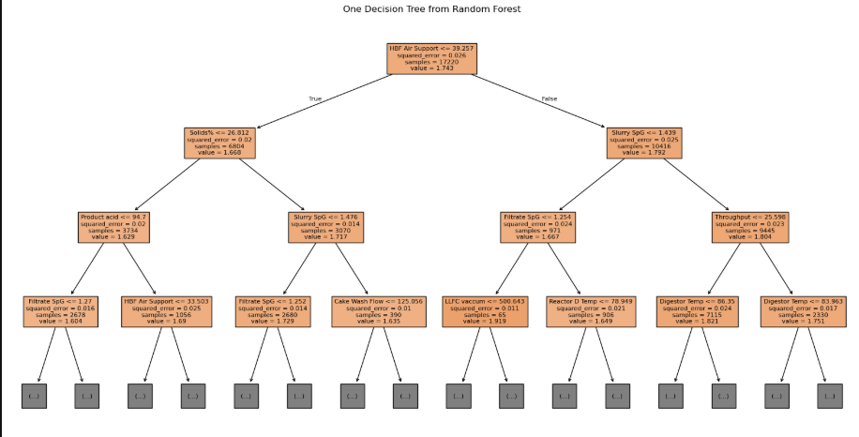

Feature Importance Analysis
The feature importance analysis identifies the relative contribution of each process variable to the prediction.
Among all variables, HBF Air Support achieved the highest importance score (approximately 17.7%), making it the most influential parameter in predicting Free Acid.
The next most significant variables include:
- Slurry Specific Gravity
- Filtrate Specific Gravity
- Digester Temperature
- Solids %
- HBF Speed
- Cake Wash Temperature
These variables contribute substantially to the predictive performance of the model and indicate that both filtration and digestion process parameters strongly influence Free Acid.
On the other hand, Agitator current measurements (A, B, C, and D) exhibited very low importance scores, suggesting that their contribution to the prediction is comparatively limited within the current dataset.
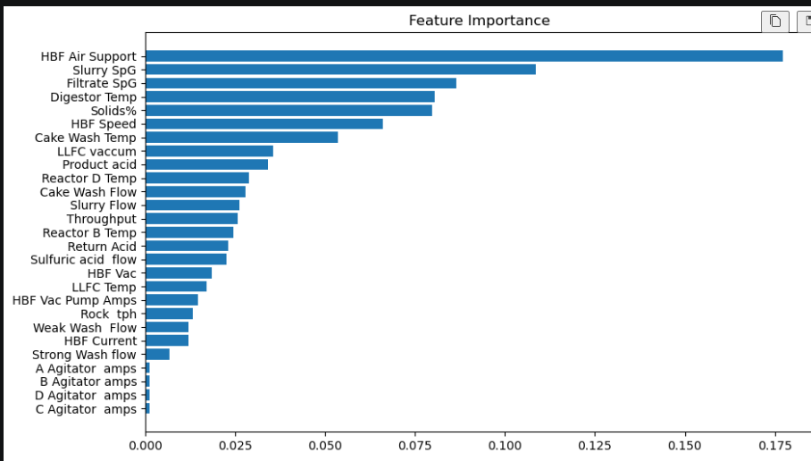
SHAP Summary Analysis
To improve model interpretability, SHAP analysis was performed.
The SHAP summary plot ranks the features according to their overall impact on model predictions.
The analysis confirms that HBF Air Support consistently exerts the strongest influence on the predicted Free Acid values.
The SHAP values further reveal that higher values of HBF Air Support generally increase the model prediction, whereas lower values tend to reduce it.
Similarly, variables such as HBF Speed, Digester Temperature, Slurry Specific Gravity, and Filtrate Specific Gravity also exhibit significant contributions to the prediction.
Unlike conventional feature importance, SHAP not only identifies important variables but also explains whether each feature positively or negatively influences the prediction for individual observations.
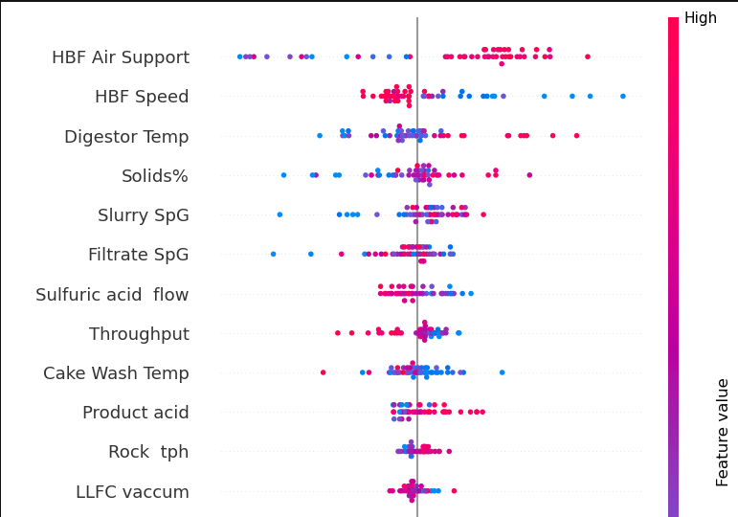=
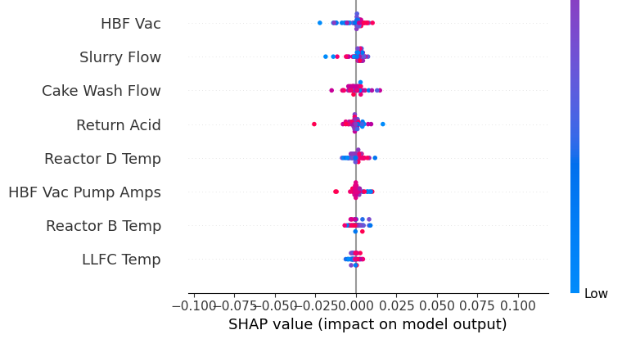
SHAP Dependence Analysis
The SHAP dependence plot illustrates the relationship between HBF Air Support and its contribution to the predicted Free Acid.
The plot indicates that as HBF Air Support increases, the SHAP value generally becomes more positive, meaning that higher air support tends to increase the predicted Free Acid under many operating conditions.
The colour gradient, representing Weak Wash Flow, suggests that interactions between HBF Air Support and Weak Wash Flow also influence the prediction.
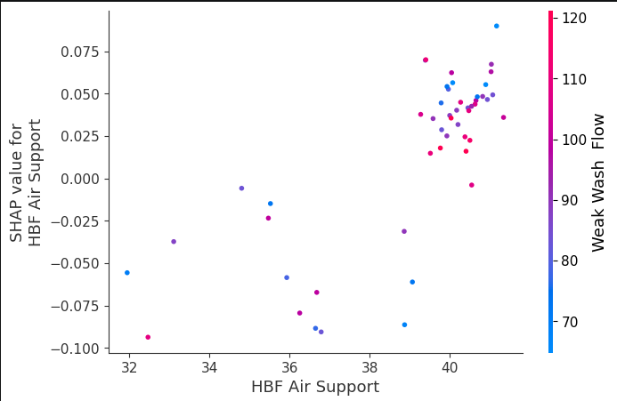

Overall Interpretation
Based on the Decision Tree, Feature Importance, and SHAP analyses, the Random Forest model demonstrates excellent capability in learning complex nonlinear relationships within the industrial process data.
The analysis consistently identifies HBF Air Support as the dominant factor influencing Free Acid prediction, followed by Slurry Specific Gravity, Filtrate Specific Gravity, Digester Temperature, Solids %, and HBF Speed.
The agreement between Feature Importance and SHAP analysis increases confidence in the reliability and interpretability of the developed model.
These findings establish Random Forest as a strong baseline model while also providing motivation for investigating more advanced ensemble learning techniques.

